Heydent website:
Packable composite

-HeyTec-NC : light-curing nano ceramic filling material and a multi-talent for long-lasting fillings, with significantly reduced sensitivity to ambient light and excellent physical values with 86% Fillers
indicated for restorations of all cavity classes and for making inlays, onlays and veneers.
-Vickers Hardness ≥847 MPa Flexural Strength ≥157 MPa E-Module 16.575 MPa Compressive Strength ≥502 MPa Tensile Strength ≥56 Mpa
-1x 5g syringe

HeyTec-Universal : was developed for users who only want to use a shade-adaptive composite which can be used for all natural tooth shades “Chameleon effect”
shows excellent physical properties and good handling features. The total filler content is 75 % by weight.
-Vickers Hardness 784 MPa Flexural Strength 157 MPa E-Module 11.173 GPa Compressive Strength 502 MPa
-1x 4g syringe

HeyTec-MR :is a universal light cure filling material with a high content of inorganic filler (75%).
HEYTEC-MR is perfect for direct restorations in both the anterior and posterior areas and for making inlays, onlays and veneers.
HEYTEC-MR is also suitable for core build-up and extended fissure sealing.
The special combination of macro and micro fillers gives HEYTEC-MR its outstanding physical properties and makes it easy to polish.
-Vickers Hardness ≥784 MPa Flexural Strength ≥157 MPa E-Module 11.173 MPa Compressive Strength ≥502 MPa Tensile Strength ≥56 MPa
-1x 4g syringe

HEYTEC BLEACH & BLEACH-X : is a ceramic hybrid composite material which is widely used for direct composite veneer cases. The excellent handling and material properties guarantee highly esthetic works. HEYTEC BLEACH is already white, but the extra bleach color is even whiter.
-Bleach: White , Bleach X: Whiter
-1x 5g syringe

Flowable composite

HEYTEC-Bulk UD : is a flowable composite for direct fillings, using the Bulk Fill technique up to 4mm layers. Thanks to the optimal ratio of flowability to elasticity. It is universal dentin shade with “chameleon” effect.
-The special monomer matrix (Bis-GMA free) ensures that the material adapts perfectly to cavity walls, even with the presence of undercuts.
-It is intended for single-step reconstructions, but also layer technique.
-Vickers hardness ≥737 MPa Flexural strength ≥134 MPa E-Module 11.090 MPa Compressive strength ≥381 MPa Filler Content 77%
-1x2g syringe

HeyTec-Flow-V : is a new generation of a light-curing and radiopaque flow composite for direct restorations,
relinings, as well as sealing fissures.
-HEYTEC-Flow-V is flowable as well as viscous when necessary and adapts nicely to cavity walls.
-Bis-GMA free
-Vickers hardness ≥794 MPa, Flexural strength ≥144 MPa, E-Module 12.316 MPa, Compressive strength ≥431 MPa, Filler content approx. 77%

Bond

H-ETCHBOND : is a self-etching, light-curing one-component, single-layer bonding system of the seventh generation.
-Only one layer of H-ETCHBOND is required to obtain a strong and long lasting bond of light-curing composites to enamel and dentin.
H-ETCHBOND is suitable for:
- Cementation of light-curing restorative composites
- Core build-ups with light and dual-curing composite
- Adhesive cementation of indirect ceramic and composite restorations with light- or dual-curing luting composites
- Repair of light-curing composite restorations
H-ETCHBOND contains:
-10-MDP (Methacryloyloxydecyldihydrogen phosphate) and 4-Meta (4-Methacryloxyethyltrimellitate anhydride) are used as acid components, which are immobilized by light polymerization
10-MDP is a phosphoric acid methacrylate forms a strong bond to hydroxyapatite.
4-Meta is a carboxylic acid combines with hydroxyapatite. It infiltrates the dentin surface very well.
Both acid components also promote the coagulation of proteins in the dentinal fluid. This contributes to the mechanical sealing of the tubules. Hypersensitivities are hereby reduced.
The monomers are optimally matched to each other to achieve the desired hydrophilicity
-1x bottle a 5ml
Veneer Cement

HEYTEC Cem Veneer: is a light-cure, single component, highly radiopaque luting material for cementing porcelain, composite and ceramic veneers and for cavity lining.
HEYTEC Cem Veneer is BisGMA, Bis EMA and TEGDMA free and highly viscous. It offers easy handling and excellent color stability for highly esthetic veneer cases.
-Filler Content 80% Compressive strength - >320 MPa Flexural strength - >115 MPa Film thickness - 28um - E-Module - >14900 MPa
-1x 2g syringe
Teeth Whitening

JW NEXT Power Bleaching: is a two components chair-side bleaching gel in a double-bar cartridge with 35 % content of active ingredient (hydrogen peroxide) for quick bleaching and brightening of discolored and devitalized teeth.
-JW NEXT Power Bleaching can be used without any light source, but gets better results with lamps and best results with a diode-laser

High content of active ingredients | Quick bleaching and brightening safe success. Long-lasting result. Gentle on the teeth.
Best Quality | Ensures the best possible results in the shorts possible time
Gentle for the teeth | No more desensitizer is needed after whitening
Contains Minerals | Thoroughly protects the teeth
Neutral pH-Value | No damage to the tooth surface
Ideal consistency | No running, good contrast on the tooth
Auto-mix cartridge | No mixing necessary, consistent quality
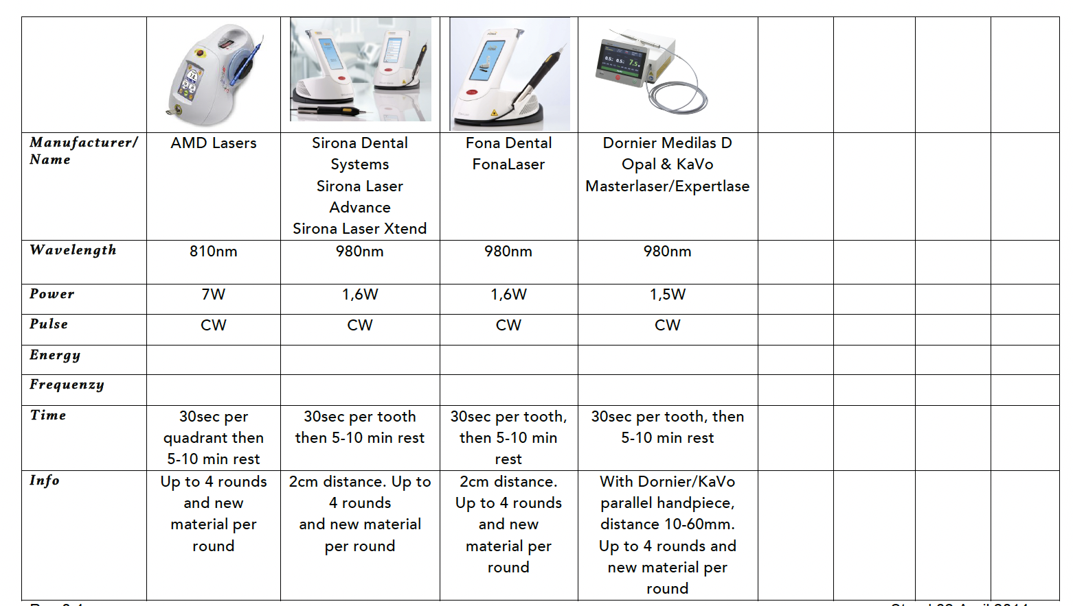
-1x 5g Double cartridge, 1x 1,5g JW Liquid Dam, 3x Mixing Tips, 1x Liquid Dam tip
